**Title:**

The effect of quantitative genetic processes on eco-evolutionary dynamics of competition

**Authors:**

*Mihir S. Umarani1, Catherine H. Graham2, Carlos J. Melian3, Stephen B. Baines1

*  corresponding author

Address:

1. Department of Ecology and Evolution, Stony Brook University, Stony Brook, New York, USA
2. Biodiversity and Conservation Biology, Swiss Federal Research Institute WSL, Zürcherstrasse 111, 8903 Birmensdorf, Switzerland
3. Department of Fish Ecology and Evolution, Centre of Ecology, Evolution and Biogeochemistry, EAWAG Swiss Federal Institute of Aquatic Science and Technology, Zurich, Switzerland

**(Short Running Title:** Evolutionary ecology of competition)

**Keywords**: Coevolution, competition, quantitative genetics, Lotka-Volterra dynamics, network structure, trait overdispersion

**Type of article**: Letter

Abstract: ___ words; Main body: 5785 words; 56 References; 6 Figures

Correspondence: Mihir S. Umarani, mihir.umarani@stonybrook.edu

**Abstract:**

Interspecific competition plays a crucial role in trait evolution yet finding its signature on natural multispecies communities remains challenging. The dependence of eco-evolutionary dynamics of multispecies competition on various ecological contexts is well-studied but effect of underlying quantitative genetic mechanisms is not sufficiently explored. We use a simple Lotka-Volterra dynamic-based model of trait-mediated competition to explore the influence of two contrasting quantitative genetic models of trait inheritance over different ecological contexts of trait-based competition. We show that the quantitative genetic processes greatly influence the species coexistence, and the trait distribution patterns across communities. We highlight the crucial role of within-species trait distributions that modulate the trait evolutionary dynamics and may induce deviations from the expected trend of trait divergence.

**Introduction:**

Interspecific competition often plays a central but potentially complex role in trait evolution (e.g., Connell, 1980; Roughgarden, 1983; Schluter, 1994; Schoener, 2006; Davies et.al., 2007). Competition arises from overlapping niches and is assumed to result in either exclusion or lowering of niche overlap through trait evolution (Schluter, 1994). Theoretical literature predominantly supports the view that reduction in niche overlap through natural selection should result in divergence in key traits of a pair of competing species (e.g. Reviewed in Abrams, 2000). Experimental studies have demonstrated these patterns using simple systems of pairwise interactions (e.g., Taper, 1990; McGoey and Stitchcombe, 2009, Terhorst, 2011). A few empirical studies also show that traits related to resource acquisition are noticeably more distinct for two similar species when they are in allopatry (e.g. Lack, 1947; Grant 1972; Reviewed in Pfenning and Pfenning, 2010) indicating a role of competition in character displacement. Intuitively, the overdispersion of traits that mediate competition should be a signature of competition’s effect on species rich communities (e.g., Losos 2008; Cavander-Bares et.al. 2009; Emerson and Gillespie, 2008). Failure to detect overdispersion in such traits is taken as evidence that competition plays little role in structuring communities.

However, the generality of such expectations has been challenged and alternative theoretical possibilities have been presented. Many studies have described specific ecological contexts which may lead to convergent trait evolution with arbitrarily similar species coexisting in a community (e.g., Roughgarden 1974; Scheffer and Van Nes 2006) . Also, the recent proliferation of data on detailed species interaction networks for species-rich communities has revealed the prevalence of highly modular structures i.e. presence of strong interactions among subsets of species in communities (e.g., Montoya et.al., 2015; Dattilo et.al., 2013). These structures represent a prevalence of high overlap in their resource use indicating persistent competitive interactions. The apparent paradox raised by such theoretical and empirical works has yet to be sufficiently explained. Thus, it becomes important to identify the conditions under which competition may or may not lead to trait-overdispersion patterns if we are to accurately test the importance of competitive interactions in structuring communities with the growing body rich empirical data.

Previous theoretical approaches predominantly have been based on niche theory which allows one to describe competition as an overlap in niches. To create a niche theory-based construct for competitive eco-evolutionary dynamic, one must describe two components: a) how the traits of the competitors represent their niches and, consequently, the strength of competition between them and b) how the trait distributions alter and propagate in response to selection due to competition.

The first component is related to the ecological context of the competition and alludes to functions called competitive kernels which describe how the strength of competition depends on the trait difference between competing individuals. Importantly, mean fitness of competing species is proportional to the competition kernel summed over trait distributions of the species. A Gaussian function is commonly used to characterize the kernel function since it is easy to analyse and reflects the idea that more similar the competitors are, more strongly they affect each other (Abrams 2000; Nuismer, Jordano, and Bascompte 2013; Nuismer and Harmon 2015). However, it may not be fit for all the competitive scenarios. Indeed, alternative forms of the competition kernels are previously analysed and are known to influence the population and trait dynamics (Leimar et al. 2013).

The second component represents the evolutionary context and alludes to the quantitative genetic mechanism that dictates how the trait distribution characteristics (shape and centralities) are inherited in response to selection and reproduction processes. This is a crucial but often overlooked part of the evolutionary process. The classic result of symmetric trait divergence shown by Slatkin (1980) and Taper and Case (1985), is a result of a Gaussian competitive kernel acting upon normally distributed traits of the competing species. In this example, it is assumed that the traits inherit the normality and the variance through generations and therefore produce consistent and symmetric fitness effects over generations, leading to the species’ trait means diverging away at the same rate. However, the trait distributions and their characteristics might alter significantly under various quantitative genetic mechanisms leading to highly dynamic feedback between the selection pressures and trait distributions. We should examine how ecological context, described by different competitive kernels, may interact with inheritance mechanisms to influence coevolutionary dynamics between competing species in communities.

In this study, we employ Lotka-Volterra-based discrete time model to simulate the effect of different competitive kernels on population and trait dynamic of multiple species. We choose different forms of competitive kernel functions that are essentially applied at the individual level of competition and we calculate their effect on species’ population growth rate i.e. the absolute fitness. We also employ two different quantitative genetic models of inheritance; quantitative genetic limit model (Lande 1976; Falconer, 1981; Barton et al., 2017) and a Shpak-Kondrashov Hypergeometric model of finite loci (Shpak and Kondrashov, 1999) to simulate the propagation of quantitative traits in response to selection and reproduction events. Using this framework, we provide predictions about how different network patterns emerge and persist as well as coevolutionary trends in trait values among the species in a model community.

We find that the evolutionary trends are sensitive to the quantitative genetic structure of the traits. When traits are under quantitative genetic limit, they follow the expected pattern of divergence under competition and the pattern is generally robust to different competition kernel functions. However, strong deviations from the pattern of trait overdispersion are possible when traits are governed by fewer number of loci (under the hypergeometric model) and the chance of observing such deviations is closely associated with the characteristics of the competitive kernels.

**Methods:**

We use a niche theoretic construct based on Taper and Case (1985). This construct can be summarized as follows: It is assumed that the consumer species compete for resources whose abundance can be mapped over a single resource trait axis (e.g., body size of prey, corolla length of flowering species etc.). Similarly, resource niches of consumer species are unidimensional across a single common trait (e.g., body sizes of predators or proboscis/beak length of nectar feeders etc.) and there is one-to-one mapping of an individual consumer’s trait and the mean resource trait it consumes. Therefore, the strength of competition between individuals of traits z and z’ is simply the overlap between resource utility curves of those individuals across resource trait axis and it is also a function of difference between z and z’. This function is commonly called a competitive kernel.

*Model description:*

The objective is to describe trait and population dynamics of multiple competing species with at least one common set of resources. The broad framework is based on classic studies of quantitative genetic models of competition (Slatkin, 1979; Taper and Case, 1985). We assume that in a community, populations of *n* species compete via a single common functional trait. Thus, only the phenotypic value of interacting individuals determines the strength of the interspecific competition, not the species’ identity. We also assume that competition is the only force of selection that acts upon the trait and determines the strength and directionality of trait evolution. All the species’ populations are assumed to be made of randomly mating diploid populations with nonoverlapping generations. Their traits follow an identical quantitative genetic mechanism of inheritance.

Species first undergo selection and then pass on the trait to the next generation via reproduction. The selection process alters the population abundances and the phenotypic distribution. It essentially represents the intrinsic growth of the population and the effect of competition on absolute fitness of the populations. The reproduction process, however, is assumed to only alter the phenotypic distribution through the explicit underlying genetic mechanism and random mating.

Population growth under selection is modelled using a discrete time Lotka-Volterra equation for competition. Growth rate or the absolute fitness of an individual with trait value z is a function of the phenotype’s intrinsic growth rate (growth rate in the absence of any competition), minus the collective effect of all intra- and interspecific competitive interactions of co-occurring phenotypes. Growth rate (or the fitness) of phenotype *z* of species *i* can be written as (Lande, 1979; Taper and Case, 1985; Barabás & D’Andrea, 2016)

|  |  |  |
| --- | --- | --- |
|  | , | (1) |

where *ri* is the intrinsic growth rate for species *i* and *Ni* is the population size of species *i*. Aij modulates the overall effect of competition and is intended to distinguish the impacts of intra- and interspecific competition. For intraspecific competition (i=j), Aij is fixed at 1indicating that per capita effect of intraspecific competition is always stronger than or equal to the effect of interspecific competition. Intrinsic growth rates, *ri*, are assumed to be independent of phenotypes except at the extreme values representing physiological limits. To implement this effect, the growth of a total population is sharply reduced when the mean phenotypic values are near the phenotypic limits.

The competition kernel, *α*, shows the strength of competition between a pair of individuals as a function of their phenotypic values, *z* and *z’*. We used two different functional forms for competition kernels. The first,

|  |  |  |
| --- | --- | --- |
|  |  | (2) |

is a Gaussian function with bounds where the strength of competition is zero when the difference between the phenotypic values of competitors is larger than some threshold t*. The other parameter, *ω,* is called the width of the competition which determines the rate of decrease in interaction strength as the trait difference becomes larger (Barabás & D’Andrea, 2016; Nuismer & Harmon, 2015). The second function we employed was a triangle function where the strength of competition decreases linearly with the difference in phenotypic values of competitors.

|  |  |  |
| --- | --- | --- |
|  |  | (3) |

To obtain the population growth rate for a given species, the equation 1 is integrated over the phenotypic abundance distribution of the species.

|  |  |  |
| --- | --- | --- |
|  | , | (4) |
|  |  |  |
|  |  |  |

Where, pi(z,t) is the phenotypic abundance distribution of species *i* and Ni is the total population size.

The expression of changes in trait means is derived using breeder’s equation (Falconer, 1981). It is based on the analysis by Barabas and D’Andrea (2016).

|  |  |  |
| --- | --- | --- |
|  |  | (5) |

where µi is the mean phenotypic value of species *i* and *hi* is the heritability of the trait. Heritability values are assumed to be constant for all the species.

|  |  |  |
| --- | --- | --- |
|  |  | (6) |

Note that the double integral term (expression 6) in the eq.5 denotes the per capita effect of pairwise competition on the directionality and the strength of trait evolution. It depends on the competition kernel as well as phenotypic distributions within the species. We further analyze the properties of this term as it is crucial in determining the theoretical conditions under which trait divergence trends may be observed.

The inheritance process is described using two different models of quantitative genetics. First, the quantitative genetic limit (QGL) model assumes that the trait is determined by large number of independent loci which contribute infinitesimally towards the individual’s phenotypic value. It also states that the phenotypes of a population remain normally distributed during trait evolution under selection, and that the variance of this distribution changes very little in response to selection.

The second model, Shpak-Kondrashov (SK) model, assumes that the trait is governed by a limited number of loci which contribute additively to the phenotypic value of an individual. Phenotypic distribution of offspring from parents with two phenotypes follows an approximate hypergeometric distribution and thus allows the trait distributions to vary in its shape, mean and variance in response to selection and reproduction. In the absence of selection pressure,any arbitrary phenotypic distribution eventually converges to Normal distribution under random mating (Shpak and Kondrashov 1999; Yamauchi and Miki 2009). Traits determined by higher number of loci reach the normal distribution faster. Thus, QGL model, which assumes that large number of loci govern the functional trait, effectively represents one extreme of the SK model in the absence of selection.

*Parameters of interest:*

We focused on five parameters of this model that influence the competition dynamic: two of them, ω (width of competition) and t* (trait difference threshold to competition) describe the trait-matching model between competing individuals and determine the shape of the competition kernel (Fig. 1B). These two parameters dictate the trait-mediated mechanism between competing individuals. Higher values of ω indicate stronger competition between individuals with given trait values while the threshold values, t*, determine whether individuals compete or not based on their trait values. Two other parameters relate to the trait distribution of the species -the number of loci governing the trait and the level of intraspecific trait variation. By varying number of loci, we represent the spectrum of underlying quantitative genetic processes of trait inheritance. Any finite number of loci determining a trait value represents the case under Shpak-Kondrashov model while the quantitative genetic limit model is assumed to represent the case where the number of loci determining a trait value is effectively infinite. Intraspecific trait variation is shown to be a critical factor in the population and evolutionary dynamic (Wittmann et al. 2006; Barabás and D’Andrea 2016). Within our framework, the trait variation affects the species’ response to selection pressure; higher trait variance will lower the rate mean trait change for a given species. The fifth parameter, *Aij*, represents the relative weight of interspecific competition compared to intraspecific competition. It is a critical parameter for the population dynamic since it can adjust the destabilizing effects of interspecific competition. While the individual influence of these parameters on species’ trait evolution can be deduced from the formulations above, their collective impact on community level emergent properties is difficult to assess. Thus, we simulated population and trait dynamics of varying assemblages of competing species and assessed the combined influence of these three parameters on community level patterns.

*Simulating trait, population, and community dynamics*

For each initial assemblage of 20 species, we generated 216 distinct combinations of parameters by varying values for the 5 parameters described above in a factorial design. The threshold to competition, *t\**, was either non-existent (infinitely large threshold) or had three levels (stringent, intermediate, and weak). The width of competition, ω, was set to one of 0.5, 1, or 2. The standard deviation for the trait distribution of each species was chosen from one of the two uniform distributions - low: [0.5,1.5], high: [2.5,3.5]. The parameter values are chosen in reference to arbitrarily chose range of plausible phenotypic values between -5 and 5. The number of loci were either 20, 50 or infinite (represented by the QGL model). and relative interspecific competition, Aij, was set at 0.1,0.5 or 0.9.

We incorporated these parameter combinations with 50 randomly sampled values of initial conditions for initial trait means, population sizes and intrinsic growth rates. Initial trait means were randomly sampled from a Normal distribution with mean 0. Initial population sizes and intrinsic growth rate values were sampled from random uniform distributions. Narrow-sense heritability was fixed at 0.5. These choices produced a large variation of initial network structures within each parameter set. We deliberately seeded our simulations with trait distributions that ensured that species’ traits were very similar and thus they were competing strongly at first. This scenario resembles the diversification of a clade of similar species evolving to exploit a wide niche space in a newly colonized habitat. Each simulation was run for 50,000 generations, which ensured that the most dynamic portion of the evolutionary sequence was observed, and that the simulation reached a state of very minimal change. During the simulation, species whose populations went below zero were removed and labelled as ‘extinct’. Population and trait dynamics following the equations above were simulated in R. Two network characteristics were tracked through the simulation period: Connectance, which measures a proportion of realized pairwise interactions (weighted by the strength of interaction) to all the potential pairwise interactions in the network and maximum modularity, which measures the prevalence of subgroups within the network, which have strong interaction within themselves (Newman and Girwan, 2002). Mean trait distribution across species was also tracked, in terms of Mean Nearest Neighborhood Distance (MNND) (Based on Findley, 1976). It is an average of nearest neighbor distances (NNDs) standardized by the maximum possible average NND given the range of trait values.

**Results:**

Two sample outcomes of the simulations are shown in Fig.2 to demonstrate the evolutionary dynamics under two quantitative genetic processes acting upon identical initial community assemblies. Both the results show a general pattern of trait divergence among competing species. The rates of trait evolution are higher at the beginning of the simulation and decrease as the trait distances between species get larger. Although the dynamics in both simulations have not reached stationary states, there are striking differences in terms of the dynamics of species extinctions, trait evolution and their final distributions. Under the QGL model of inheritance, trait difference between all the pairs of species keeps increasing albeit with uneven rates. Species that reach the trait extremes rapidly go extinct. Consequently, the final distribution of mean traits across community is roughly evenly spread across the trait range. On the contrary, the evolutionary dynamic under the SK model of inheritance does not always increase the distance between traits of pairs of species. Extinctions also occur but they are not primarily for the species with more extreme trait values. Species with more extreme trait values undergo population reduction as they experience sharp decline in intrinsic growth rates similar to the QGL model, but they take significant amount of time to become extinct. The final mean trait distribution across species shows clusters of species with similar traits strongly competing.

Figures 3,4 and 5 show that the community-level patterns are strongly driven by the quantitative genetic inheritance process while initial trait distributions and demographic conditions have little impact. The QGL and SK inheritance models differed markedly in the dynamics of the mean trait distributions and network structures across the community. Although the species level dynamics show highly variable patterns between simulations, these differences were robust across different parametric scenarios.

Species richness declined rapidly with time for the simulations under the QGL model while the decline was gradual for those under the SK model (Fig.3). The SK model shows that the richness patterns remain highly persistent. In case of the QGL model, different competitive kernels did not alter the overall dynamics strongly whereas the initial trait distributions and demographic conditions had strong impact on the extinction rates. In contrast, under the SK model, wider width of competitive kernels (omega) strongly increased the extinction rates while the trait thresholds to the competition did not influence the dynamics strongly. Interestingly, the strength of interspecific competition relative to the intraspecific competition did not alter the extinction rates or the dynamics under either inheritance model.

Maximum modularity, which measures the presence of strong clusters of species competing within the network, showed opposing temporal trends for QGL and SK models (Fig.4). Under QGL model, the networks consistently became less modular with time while modularity values under the SK model seemed to converge to higher values. These trends were also robust towards differing initial trait and demographic conditions. Interestingly, different parameter combinations about the strength of interspecific competition and the competitive kernels influenced the trends differently under two inheritance models. For the QGL model, higher strength of interspecific competition relative to the intraspecific competition strongly accelerated the decreasing trend for the maximum modularity while it did not have a strong impact under the SK model. However, under the SK model, the effect of the wider width of the competition kernel decelerated the increasing trend in modularity under weak interspecific competition while it accelerated the increasing trends under strong interspecific competition. Different trait thresholds to competitive kernels showed no significant marginal effects on the modularity dynamics of evolving networks.

The mean trait dispersion across competing species, measured as Mean Nearest Neighbor Distance (MNND), also showed contrasting patterns across two quantitative genetic inheritance models (Fig.5). Under the QGL model, MNND values reached the maximum value of 1 for all combinations of competitive scenarios indicating an overdispersion of mean trait values. The qualitative trend and the rate of change were not heavily affected by either the initial trait and demographic conditions or different competitive parametric conditions. Under the SK model, the qualitative trend of decrease was not affected by the parametric conditions but the rates of decrease in MNND values were influenced by the strength of interspecific competition as well as the competitive kernels. The contrast in trends is apparent between the top-left panel and the bottom-right panel under the SK model in Fig. 5. Competitive kernels with strong trait threshold and narrower widths under strong effect of interspecific competition showed deceleration in the dynamic of trait dispersions.

**Discussion:**

Our results highlight that the quantitative genetic process of trait inheritance has a great influence on evolutionary trends of species under competition. Simulations of eco-evolutionary dynamics under two such models, Quantitative Genetic Limit model (QGL) and Shpak-Kondrashov model (SK) showed great contrast in the dynamic trends of community-level characteristics such as network modularity and mean trait distributions. Under the quantitative genetic limit (QGL) model, the expected trait divergence pattern is generally observed. Altering the competitive kernels, which represents the ecological mechanisms of competition, does not change these general trends. However, when the trait is governed by a finite number of loci under the SK hypergeometric model, we observe strong deviations from the trait overdispersion observed in the QGL model. Some aspects of trait dynamics under the SK model depend on the characteristics of competitive kernels, but the qualitative differences are robust to all scenarios. These deviations are the direct results of the convergent evolutionary trajectories, instances of which are observed in Fig.2b.

These results highlight a simple but crucial mechanism regarding diffuse competition. Within our framework, if only a single pair of species were to compete, their respective traits will always diverge. However, if the collective effect of diffuse competition i.e., effect of multiple competing species other than the pair of species in focus, is stronger than the effect of competition between a chosen pair of species, it is possible to observe convergent trait evolution. The β function, which describes the selection pressure on one species with the trait mean zero due to competition with species j with the trait mean µ(eq. 6), essentially dictates the relative impact of diffuse competition on the trait evolution of a given pair of species. Figure 6 demonstrates the impact of how different β functions alter the strength and direction of trait evolution. The expression of the β functions shows that its shape characteristics depend on trait distributions of species as well as competition kernel function (eq.6). If the competitive kernel is symmetric, by construct, β function is always antisymmetric around the origin. If the absolute values of function sharply rise and fall on both sides of the origin, as in panel (II) in Fig.6, the effect of the diffuse competition will be weak compared to the mutual repulsive effect between a pair of species. In such scenario, it is highly unlikely to observe convergent trait evolution. In contrast (panel (III), if the absolute values of the function rise and fall slowly away from the origin, there is a higher likelihood that the effect of diffuse competition will overpower the mutual repulsive selective force between a pair of species leading to a convergent evolution. Although, the event of convergent evolution between two species depends on the relative “positions” of other species along the trait axis, thus being highly idiosyncratic, its likelihood is modulated by the shape characteristics of the β function.

Given this premise, what are the competitive scenario or the quantitative genetic inheritance processes under which one may expect deviations from the expected trend of trait-overdispersion or limiting similarity? Based on the expression of the β function (eq.6), if the traits of both the species are normally distributed, the resulting β function takes the form from the panel (II) in Fig.6 and its shape does not alter significantly under different competitive kernels. Therefore, it is highly unlikely that competing species with normally distributed shapes would produce convergent trait trajectories and the traits should diverge away. The pioneering quantitative genetic model of resource competition (QGR model) by Slatkin (1980) and Taper and Case (1985) becomes a subset in our framework since they employ a Gaussian competition kernel and assume that the traits remain normally distributed through generations (demonstrated in Fig.1) thus resembling the functional forms shown in fig.1 and panel (II) in fig.6. In this case, our framework dictates that divergent trait evolution should be observed leading trait overdispersion pattern across the community. On the contrary, if traits of the competing species were not normally distributed, the shape of the β function may be influenced by the competitive kernel function and thus modulate the likelihood of the trait convergence events. An example of such β function is shown in panel (III) in fig.6.

Critically, the analysis of the β function above shows that the quantitative genetic inheritance processes, which determine how the traits are propagated through generations would strongly affect the evolutionary response to the competition. These effects are evident at the community-level patterns (Figs. 3,4 and 5). QGL model of inheritance assumes that the traits are determined by infinitesimally small contributions from large number of loci and retain the Gaussian shape with the variance robustly unchanged under weak directional selection. Thus, normally distributed traits under the QGL model of inheritance would lead to the general trend of trait divergence with the employment of any symmetric competition kernel function. This expectation is corroborated by the consistent trends in network modularity and the trait dispersion which are not affected by different forms of competition kernels or different initial demographic conditions.

SK model, employed to provide a dynamically sufficient (Shpak and Kondrashov 1999) contrast to the QGL model, assumes that the traits are governed by limited number of loci and the inherited traits are sampled from a hypergeometric distribution parameterized with parental phenotypic frequencies. Under the SK model, an arbitrary trait distribution is feasible even though it converges to normal distribution under pure inheritance process with random mating. However, under directional selection, the traits may not fully converge to normality and thus allow the convergent trait evolution to occur between pairs of competing species. These expectations are evident in our simulation outcomes under the SK model, where increasing modularity in networks and decreasing Mean Nearest Neighbor distances indicate the prevalence of convergent trait evolution. Interestingly, changing the forms of competitive kernels did not show a strong marginal effect on the qualitative nature of the evolutionary dynamic. Width of the competition kernel and the trait thresholds determine the overall level of competition a species experiences from the other species. Thus, these parameters modulate the selection pressure caused by competition and can accelerate or decelerate the evolutionary trends. Also, they modulate the negative impact on population growth because of competition, influencing the extinction rate, which in turn, affect the community level trait and network patterns. Therefore, the parameters related to the competition kernel play a complex role in an overall eco-evolutionary dynamic under the SK model.

These results have important implications for the empirical research that attempts to explain community level patterns of network structures and trait distributions. When a single time snapshot of a community or a trait composition is studied, an overdispersion of traits of closely related species is taken as an evidence of competition (Kraft et.al. 2008, Barotolo et.al. 2012 etc.). However, the absence of trait overdispersion does not necessarily imply that competitive interactions had an insignificant effect, and such an inference requires further support (Barabas and D’Andrea 2016, Mayfield and Levine 2010). Indeed, multiple analyses have suggested that alternative outcomes could result depending on the nature of competition, resource use characteristics, stochasticity, and environmental fluctuations (MacArthur and Levine 1967, Abrams 1983, Roughgarden 1983). Trait clustering has also been shown in prior models when communities were initially saturated with species and allowed to prune through extinction (Scheffer and Van Nes 2006). We show that such clustering arises from evolutionary dynamics of arbitrarily assembled communities and the underlying quantitative genetic processes are critical in shaping these patterns.

Importantly, we also elucidated the critical role of trait distributions in the eco-evolutionary dynamics which lends strong support to the multiple previous studies emphasizing the need to incorporate information about intraspecific trait variations in the study designs. It is commonly observed and expected that the complex traits are normally distributed within species. In such cases, it is argued that Quantitative Genetic Limit (QGL) model provides robust and dynamically sufficient representation of quantitative genetics processes. It therefore might be fair to expect the general trend of trait overdispersion across community, even though intraspecific trait variation levels do influence the coexistence patterns (supp. Info, Barabas and D’Andrea 2016). However, such expectations may break down significantly in case of rare species influenced by strong genetic drift, or if underlying genetic architecture shows strong linkages or if the populations are structured (Barton, Etheridge, and Véber 2017). We chose the SK model, just as an instance which provides a contrast to Quantitative Genetic Limit (QG) model in terms of the potentials of trait distribution shapes and their inheritance. Such deviations may not follow a quantitative genetic process as simplified as the SK model but if they cause the trait distributions deviate from Gaussian shapes, deviations from trait overdispersions or strong persistent interactions may be observed within communities.

Additionally, an understanding the characteristics of the competition kernels can be highly informative in predicting the ecological or evolutionary outcomes of competition. The shape of such kernels has rarely been characterized in natural communities. Such competitive kernels address mechanism behind how competition arises, and their shapes could capture the context specific to study systems. This could be addressed by analyses of resource utilization among consumer guilds and functional approaches that account for physical constraints on resource use.

In this framework, we assumed that the competition occurs along a one-dimensional niche represented by a single trait across competitors. But this framework can be expanded to consider multi-dimensional niches and still fundamentally address of how different competitive kernel functions and a given trait inheritance models influence the evolutionary dynamic. We also use a rather simplistic Lotka-Volterra which does not consider more than second order effects of population sizes on their growth rate. However, the outcomes remain robust near equilibrium conditions. Thus, even though the model is simplistic we argue that the fundamental mechanisms involving trait distributions and competitive kernels that lead to different evolutionary patterns are still generalizable and highlight the need to further study the impact of genetic structures of ecological traits.

**References:**

Abrams, Peter A. 2000. “The Evolution of Predator-Prey Interactions : Theory and Evidence Author ( s ): Peter A . Abrams Source : Annual Review of Ecology and Systematics , 2000 , Vol . 31 ( 2000 ), Pp . 79-105 Published by : Annual Reviews Stable URL : Https://Www.Jstor.Org/Sta” 31: 79–105.

Shpak, Max, and Alexey S. Kondrashov. 1999. “Applicability of the Hypergeometric Phenotypic Model to Haploid and Diploid Populations.” *Evolution* 53 (2): 600–604. https://doi.org/10.1111/j.1558-5646.1999.tb03794.x.

Nuismer, Scott L., Pedro Jordano, and Jordi Bascompte. 2013. “Coevolution and the Architecture of Mutualistic Networks.” *Evolution* 67 (2): 338–54. https://doi.org/10.1111/j.1558-5646.2012.01801.x.

Taper, M. L., and T. J. Case. 1992. “Models of Character Displacement and the Theoretical Robustness of Taxon Cycles.” *Evolution* 46 (2): 317–33. https://doi.org/10.1111/j.1558-5646.1992.tb02040.x.

Yamauchi, Atsushi, and Takeshi Miki. 2009. “Intraspecific Niche Flexibility Facilitates Species Coexistence in a Competitive Community with a Fluctuating Environment.” *Oikos* 118 (1): 55–66. https://doi.org/10.1111/j.1600-0706.2008.16736.x.

Gouws, E. Jeanne, Kevin J. Gaston, and Steven L. Chown. 2011. “Intraspecific Body Size Frequency Distributions of Insects.” *PLoS ONE* 6 (3): 1–8. https://doi.org/10.1371/journal.pone.0016606.

Kelt, Douglas A., and Marc D. Meyer. 2009. “Body Size Frequency Distributions in African Mammals Are Bimodal at All Spatial Scales.” *Global Ecology and Biogeography* 18 (1): 19–29. https://doi.org/10.1111/j.1466-8238.2008.00422.x.

Jauker, Frank, Martin Speckmann, and Volkmar Wolters. 2016. “Intra-Specific Body Size Determines Pollination Effectiveness.” *Basic and Applied Ecology* 17 (8): 714–19. https://doi.org/10.1016/j.baae.2016.07.004.

Kalyuzhny, Michael, Ronen Kadmon, and Nadav M Shnerb. 2015. “A Neutral Theory with Environmental Stochasticity Explains Static and Dynamic Properties of Ecological Communities.” *Ecology Letters* 18 (6): 572–80. https://doi.org/10.1111/ele.12439.

Manceau, Marc, Amaury Lambert, and Hélène Morlon. 2015. “Phylogenies Support Out-of-Equilibrium Models of Biodiversity.” *Ecology Letters* 18 (4): 347–56. https://doi.org/10.1111/ele.12415.

Lack, D. 1945. “The Galapagos Finches (Geospizinae): A Study in Variation.” *CAlifornia Academy of Sciences*.

Findley, James S. 1976. “The Structure of Bat Communities.” *The American Naturalist* 110(971): 129–39.

Lynch, Michael, and Bruce Walsh. 1998. *Genetics and Analysis of Quantitative Traits. Vol. 1.* Sunderland: Sinauer.

Bolnick, Daniel I., Priyanga Amarasekare, Márcio S. Araújo, Reinhard Bürger, Jonathan M. Levine, Mark Novak, Volker H.W. Rudolf, Sebastian J. Schreiber, Mark C. Urban, and David A. Vasseur. 2011. “Why Intraspecific Trait Variation Matters in Community Ecology.” *Trends in Ecology and Evolution* 26 (4): 183–92. https://doi.org/10.1016/j.tree.2011.01.009.

Taper, Mark L. 1990. “No TitleExperimental Character Displacement in the Adzuki Bean Weevil, Callosobruchus Chinensis.” In *Bruchids and Legumes: Economics, Ecology and Coevolution*, 289–301. Dordrecht: Springer.

Mayfield, Margaret M., and Jonathan M. Levine. 2010. “Opposing Effects of Competitive Exclusion on the Phylogenetic Structure of Communities.” *Ecology Letters* 13 (9): 1085–93. https://doi.org/10.1111/j.1461-0248.2010.01509.x.

Pfennig, David W., and Karin S. Pfennig. 2010. “Character Displacement and the Origins of Diversity.” *American Naturalist* 176 (SUPPL. 1): 26–44. https://doi.org/10.1086/657056.

GRANT, P. R. 1972. “Convergent and Divergent Character Displacement.” *Biological Journal of the Linnean Society* 4 (1): 39–68. https://doi.org/10.1111/j.1095-8312.1972.tb00690.x.

GRANT, P. R. 1972. “Convergent and Divergent Character Displacement.” *Biological Journal of the Linnean Society* 4 (1): 39–68. https://doi.org/10.1111/j.1095-8312.1972.tb00690.x.

Farias, Ariel A., and Fabian M. Jaksic. 2007. “Effects of Functional Constraints and Opportunism on the Functional Structure of a Vertebrate Predator Assemblage.” *Journal of Animal Ecology* 76 (2): 246–57. https://doi.org/10.1111/j.1365-2656.2006.01202.x.

Son, Thijs Christiaan Van, and Martin Thiel. 2006. “Multiple Predator Effects in an Intertidal Food Web.” *Journal of Animal Ecology* 75 (1): 25–32. https://doi.org/10.1111/j.1365-2656.2005.01019.x.

Albrecht, M., and N. J. Gotelli. 2001. “Spatial and Temporal Niche Partitioning in Grassland Ants.” *Oecologia* 126 (1): 134–41. https://doi.org/10.1007/s004420000494.

Dáttilo, Wesley, Thiago J. Izzo, Heraldo L. Vasconcelos, and Víctor Rico-Gray. 2013. “Strength of the Modular Pattern in Amazonian Symbiotic Ant-Plant Networks.” *Arthropod-Plant Interactions* 7 (4): 455–61. https://doi.org/10.1007/s11829-013-9256-1.

Montoya, D., M. L. Yallop, and J. Memmott. 2015. “Functional Group Diversity Increases with Modularity in Complex Food Webs.” *Nature Communications* 6 (May). https://doi.org/10.1038/ncomms8379.

Emerson, Brent C., and Rosemary G. Gillespie. 2008. “Phylogenetic Analysis of Community Assembly and Structure over Space and Time.” *Trends in Ecology and Evolution* 23 (11): 619–30. https://doi.org/10.1016/j.tree.2008.07.005.

Cavender-Bares, Jeannine, Kenneth H. Kozak, Paul V.A. Fine, and Steven W. Kembel. 2009. “The Merging of Community Ecology and Phylogenetic Biology.” *Ecology Letters* 12 (7): 693–715. https://doi.org/10.1111/j.1461-0248.2009.01314.x.

Losos, Jonathan B. 2008. “Phylogenetic Niche Conservatism, Phylogenetic Signal and the Relationship between Phylogenetic Relatedness and Ecological Similarity among Species.” *Ecology Letters* 11 (10): 995–1003. https://doi.org/10.1111/j.1461-0248.2008.01229.x.

Abrams, P. 1983. “The Theory of Limiting Similarity.” *Annual Review of Ecology and Systematics. Vol. 14*, no. 34: 359–76.

Allesina, Stefano, and Mercedes Pascual. 2008. “Network Structure, Predator - Prey Modules, and Stability in Large Food Webs.” *Theoretical Ecology* 1 (1): 55–64. https://doi.org/10.1007/s12080-007-0007-8.

Rejmánek M., and P Stary. 1979. “Connectance in Real Biotic Communities and Critical Values for Stability of Model Ecosystems.” *Nature* 280 (July): 311–13.

DeAngelis, D.L. 1975. “Stability and Connectance in Food Web Models.” *Ecology* 56 (1): 238–43.

Garibaldi, Lucas A., Ignasi Bartomeus, Riccardo Bommarco, Alexandra M. Klein, Saul A. Cunningham, Marcelo A. Aizen, Virginie Boreux, et al. 2015. “Trait Matching of Flower Visitors and Crops Predicts Fruit Set Better than Trait Diversity.” *Journal of Applied Ecology* 52 (6): 1436–44. https://doi.org/10.1111/1365-2664.12530.

Newman, Ethan, John Manning, and Bruce Anderson. 2014. “Matching Floral and Pollinator Traits through Guild Convergence and Pollinator Ecotype Formation.” *Annals of Botany* 113 (2): 373–84. https://doi.org/10.1093/aob/mct203.

Zook, Alexander E., Anna Eklof, Ute Jacob, and Stefano Allesina. 2011. “Food Webs: Ordering Species According to Body Size Yields High Degree of Intervality.” *Journal of Theoretical Biology* 271 (1): 106–13. https://doi.org/10.1016/j.jtbi.2010.11.045.

Schluter, Dolph. 1994. “Experimental Evidence That Predation Promotes Divergence in Adaptive Radiation.” *Science* 266: 798–800. https://doi.org/10.1073/pnas.0601575103.

Jonathan Davies, T., Shai Meiri, Timothy G. Barraclough, and John L. Gittleman. 2007. “Species Co-Existence and Character Divergence across Carnivores.” *Ecology Letters* 10 (2): 146–52. https://doi.org/10.1111/j.1461-0248.2006.01005.x.

Schoener, Thomas W. 2006. “The Evolution of Bill Size Differences Among Sympatric Congeneric Species of Birds.” *Evolution* 19 (2): 189. https://doi.org/10.2307/2406374.

McGoey, Brechann V., and John R. Stinchcombe. 2009. “Interspecific Competition Alters Natural Selection on Shade Avoidance Phenotypes in Impatiens Capensis.” *New Phytologist* 183 (3): 880–91. https://doi.org/10.1111/j.1469-8137.2009.02934.x.

Barton, N. H., A. M. Etheridge, and A. Véber. 2017. “The Infinitesimal Model: Definition, Derivation, and Implications.” *Theoretical Population Biology* 118: 50–73. https://doi.org/10.1016/j.tpb.2017.06.001.

May, R M. 1972. “Will a Large Complex System Be Stable?” *Nature* 238: 413–14. https://doi.org/10.1038/238413a0.

May, Robert M. 1971. “Stability in Multispecies Community Models.” *Mathematical Biosciences* 12 (1–2): 59–79. https://doi.org/10.1016/0025-5564(71)90074-5.

Nuismer, Scott L., and Luke J. Harmon. 2015. “Predicting Rates of Interspecific Interaction from Phylogenetic Trees.” *Ecology Letters* 18 (1): 17–27. https://doi.org/10.1111/ele.12384.

Roughgarden, Jonathan. 1976. “Resource Partitioning among Competing Species-A Coevolutionary Approach.” *Theoretical Population Biology* 9 (3): 388–424. https://doi.org/10.1016/0040-5809(76)90054-X.

Roughgarden, Jonathan. 1983. “Competition and Theory in Community Ecology.” *The American Naturalist* 122 (5): 583–601.

Taper, Mark L., and Ted J Case. 1985. “Quantitative Genetic Models for the Coevolution of Character Displacement.” *Ecology* 66 (2): 355–71.

Barabás, György, and Rafael D’Andrea. 2016. “The Effect of Intraspecific Variation and Heritability on Community Pattern and Robustness.” *Ecology Letters* 19 (8): 977–86. https://doi.org/10.1111/ele.12636.

D’Andrea, Rafael, and Annette Ostling. 2016. “Challenges in Linking Trait Patterns to Niche Differentiation.” *Oikos* 125 (10): 1369–85. https://doi.org/10.1111/oik.02979.

Terhorst, C. P. 2011. “Experimental Evolution of Protozoan Traits in Response to Interspecific Competition.” *Journal of Evolutionary Biology* 24 (1): 36–46. https://doi.org/10.1111/j.1420-9101.2010.02140.x.

Moré, Marcela, Felipe W. Amorim, Santiago Benitez-Vieyra, A. Martin Medina, Marlies Sazima, and Andrea A. Cocucci. 2012. “Armament Imbalances: Match and Mismatch in Plant-Pollinator Traits of Highly Specialized Long-Spurred Orchids.” *PLoS ONE* 7 (7). https://doi.org/10.1371/journal.pone.0041878.

Chalcraft, David R., and William J. Resetarits. 2003. “Predator Identity and Ecological Impacts: Functional Redundancy or Functional Diversity?” *Ecology* 84 (9): 2407–18. https://doi.org/10.1890/02-0550.

Marti, Carl D, Karen Steenhof, Michael N Kochert, and Jeffrey S Marks. 1993. “Community Trophic Structure : The Roles of Diet , Body Size , and Activity Time in Vertebrate Predators.” *Oikos* 67 (1): 6–18.

Leimar, Olof, Akira Sasaki, Michael Doebeli, and Ulf Dieckmann. 2013. “Limiting Similarity, Species Packing, and the Shape of Competition Kernels.” *Journal of Theoretical Biology* 339: 3–13. https://doi.org/10.1016/j.jtbi.2013.08.005.

Roughgarden, Jonathan. 1974. “Species Packing and the Competition Function with Illustrations from Coral Reef Fish.” *Theoretical Population Biology* 5 (2): 163–86. https://doi.org/10.1016/0040-5809(74)90039-2.

Scheffer, Marten, and Egbert H. Van Nes. 2006. “Self-Organized Similarity, the Evolutionary Emergence of Groups of Similar Species.” *Proceedings of the National Academy of Sciences of the United States of America* 103 (16): 6230–35. https://doi.org/10.1073/pnas.0508024103.

Connell, Joseph H. 1980. “Diversity and the Coevolution of Competitors , or the Ghost of Competition Past.” *Oikos* 35 (2): 131–38.

**Figures:**

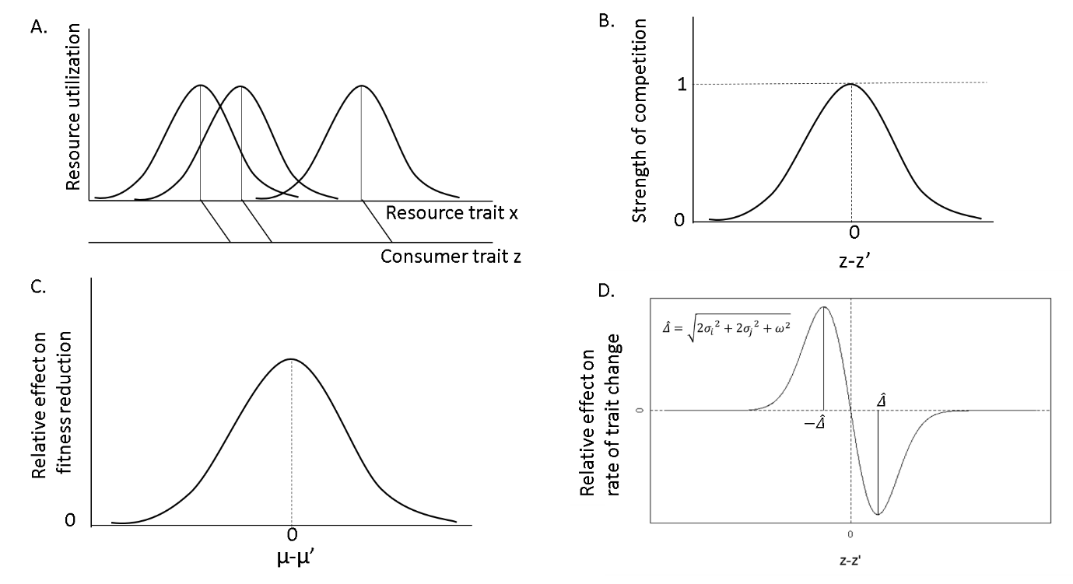

Figure1: Schematic of the niche construct used in the analysis. A. An example of Gaussian-shaped resource utilization curves of the consumer individuals. A consumer with a trait value z consumes resources of the traits distributed over resource axis with a fixed mean and a fixed variance. B. Strength of competition between a pair of consumers with traits z and z’ is derived from an overlap between their respective resource utilization curves. This function is also called a competitive kernel. C. When the effect of competition between a random pair of heterospecific individuals is added over populations, we obtain the relative reduction in fitness as a function of difference between mean traits of competing species. D. Effect of competition between two species on the rate of change in mean trait over a generation.

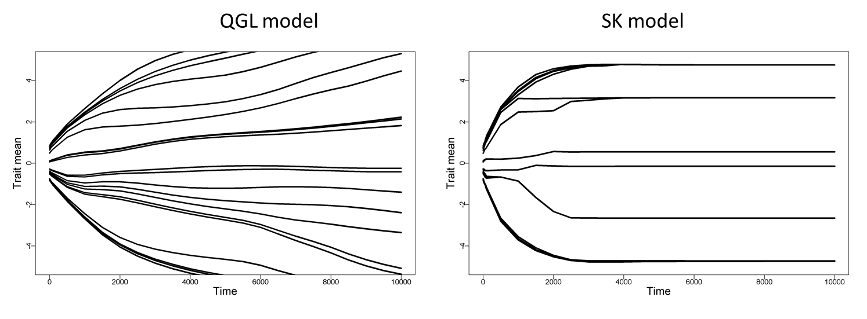

Figure 2: Sample outcomes of simulations under two quantitative genetic models, QG (left panel) and SK model (right panel). Both the plots show the evolution of mean trait values of 20 competing species with a truncated Gaussian competition kernel (Threshold=1, Width of competition=1) for 10000 generations. The thickness of the trajectories represents the relative population sizes of the species at the given time. The ends of the trajectories before the final time steps indicate the extinction events. 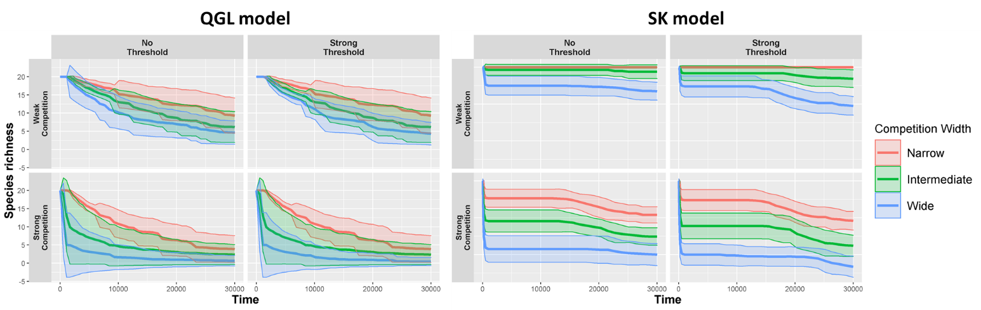Figure 3: Temporal trends in species richness of competing community are shown under two quantitative genetic processes (QG and SK model) and with different shapes of competitive kernels. The columns in each panel represent the sets of simulations with different thresholds to the Gaussian competition kernels. The rows from both the panels indicate the strength of interspecific competition relative to intraspecific competition. Within each plot, three different colored trajectories represent different widths of Gaussian kernels.

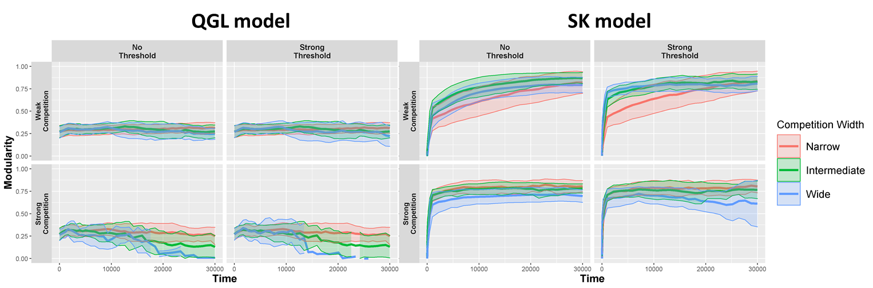

Figure 4 Temporal trends in maximum modularity of competitive networks is shown under two quantitative genetic processes (QG and SK model with 20 loci) and with different shapes of competitive kernels. The columns in each panel represent the sets of simulations with different thresholds to the Gaussian competition kernels. The rows from both the panels indicate the strength of interspecific competition relative to intraspecific competition. Within each plot, three different colored trajectories represent different widths of Gaussian kernels. Each trajectory has a bold line representing the mean values across 20 replicates that represent varying initial demographic conditions. Range around the bold lines with faded colors should variation one standard deviation around the mean.

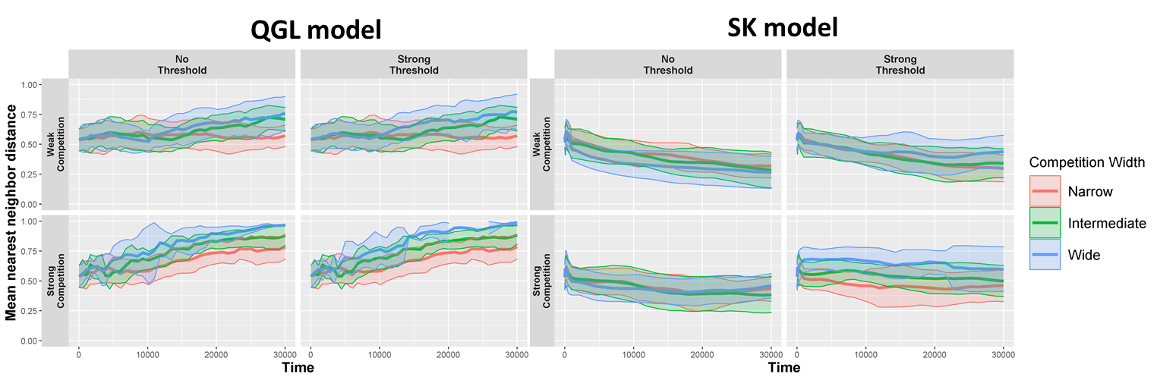

Figure 5 Temporal trends in trait dispersion patterns (Mean Nearest Neighbor distance) of trait means is shown under two quantitative genetic processes (QG and SK model with 20 loci) and with different shapes of competitive kernels. The columns in each panel represent the sets of simulations with different thresholds to the Gaussian competition kernels. The rows from both the panels indicate the strength of interspecific competition relative to intraspecific competition. Within each plot, three different colored trajectories represent different widths of Gaussian kernels. Each trajectory has a bold line representing the mean values across 20 replicates that represent varying initial demographic conditions. Range around the bold lines with faded colors should variation one standard deviation around the mean.

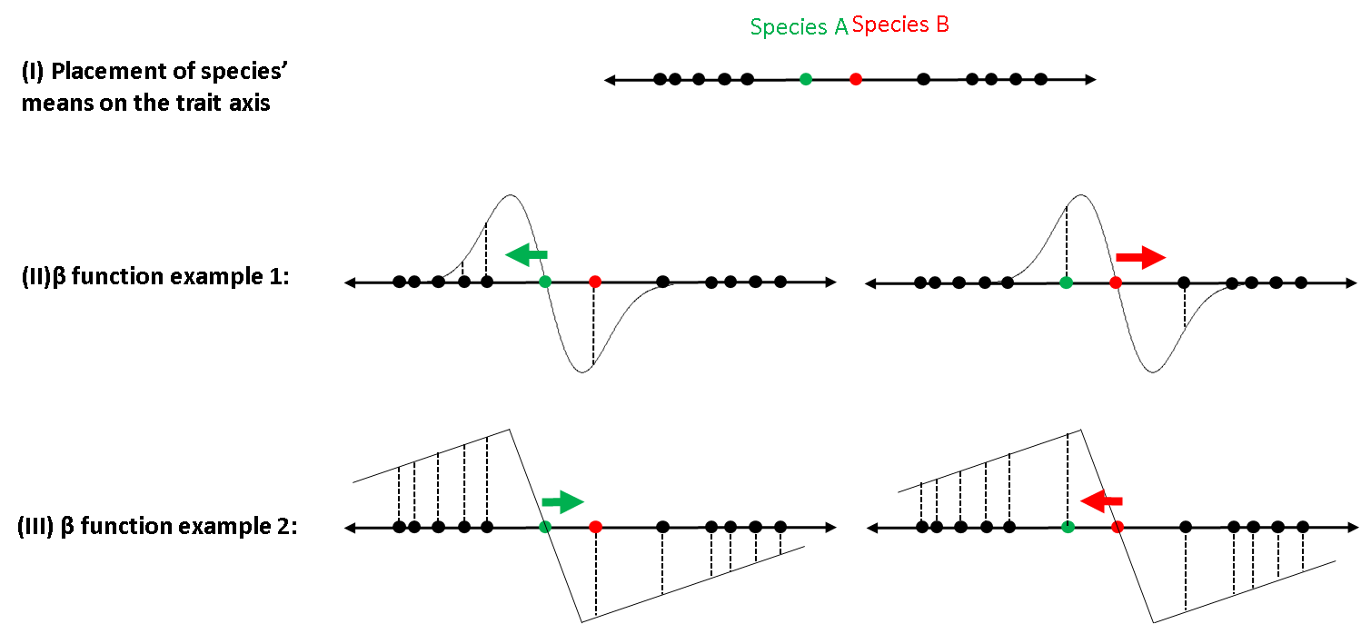

Figure 6: Demonstration of how different beta functions may lead to different evolutionary trajectories of competing species. Panel (I) shows a scenario where multiple species are competing via a single common trait and their means can be placed on a single trait axis. Two species in focus are highlighted in green and red circles. Rest of the species (in black circles) are collectively considered as a diffuse competition. Example 1 from panel (II), shows a β function curve resulting from a Gaussian competitive kernel and normally distributed traits (see eq. 6) and the effect of diffuse and pairwise competition on species A (left) and B (right) respectively. Effect of diffuse competition does not overcome the strength of repulsive effect of a competition between A and B, thus leading to diverging trait evolution of A and B. Example 2 from panel (III), on the other hand shows a β function resulting from a truncated Gaussian competitive kernel and uniformly distributed traits. In this case, the effect of diffuse competition is much stronger than the mutual repulsion between A and B, leading to convergent trait evolution.